Forex Process

Solution Design Document (SDD)



Document Version Control

|  |  |  |  |
| --- | --- | --- | --- |
| Date Issued | Version | Description | Author |
| 18-07-2022 | 1.0 | SDD for Approval | Vijay |

Document Sign-off Requirements

The following table contains the people required to sign-off and/or review this document and those that require the document for information only.

|  |  |  |
| --- | --- | --- |
| Name | Department | Responsibility |
| Satish Reddy | RPA – Project Head | Sign-off |
| Vijay Kumar | RPA BA | Information |

Table of Contents

1. **Introduction** 4

**2.** **Procedure** 4

**3.** **Documents Required for Forex** 4

**4.** **Record the value of the Transaction** 4

**5.** **Robotic Resource Requirement** 5

**6.** **Solution Design Diagram** 6

7. **Application Form** 7

**8.** **Sign-Off and Acknowledgment** 9

# **Introduction**

* 1. What is foreign exchange rate

Abstract. In finance, an exchange rate (also known as a foreign-exchange rate, forex rate, FX rate or Agio) between two currencies is the rate at which one currency will be exchanged for another. It is also regarded as the value of one country's currency in terms of another currency foreign exchange rates

Foreign Exchange Documents means the collective reference to each Foreign Exchange Agreement, each application therefor, and any other instrument, document, certificate, or agreement executed and/or delivered by any one or more of the Borrowers or any other Person under, pursuant to or in connection with any Foreign

# **Procedure**

The simplest means for currency exchange in India is through an ATM. You could use your ATM Debit Card of the country of residence to withdraw the required amount. Banks may charge an exchange rate transaction fee as well as a service fee when using your ATM card overseas

# **Documents Required for Forex**

* A valid passport.
* A valid VISA for the country you want to travel.
* Confirmed ticket (travel within 60 days once got the exchanged currency)
* PAN card.
* Aadhar card.

# **Record the value of the Transaction**

1. Record the Value of the Transaction.
2. Record the value of the transaction in dollars at the exchange rate current at the time of purchase or sale
3. Calculate the Value in Dollars.
4. Calculate the value of the payment in dollars at the exchange rate current when the transaction is settled

# **Robotic Resource Requirement**

|  |  |
| --- | --- |
| The Process will be execute | 24/7 |
| Current Volumes | 200 |
| Expected Future Volumes | 500 |
| Daily System Availability | Yes |

# **Solution Design Diagram**

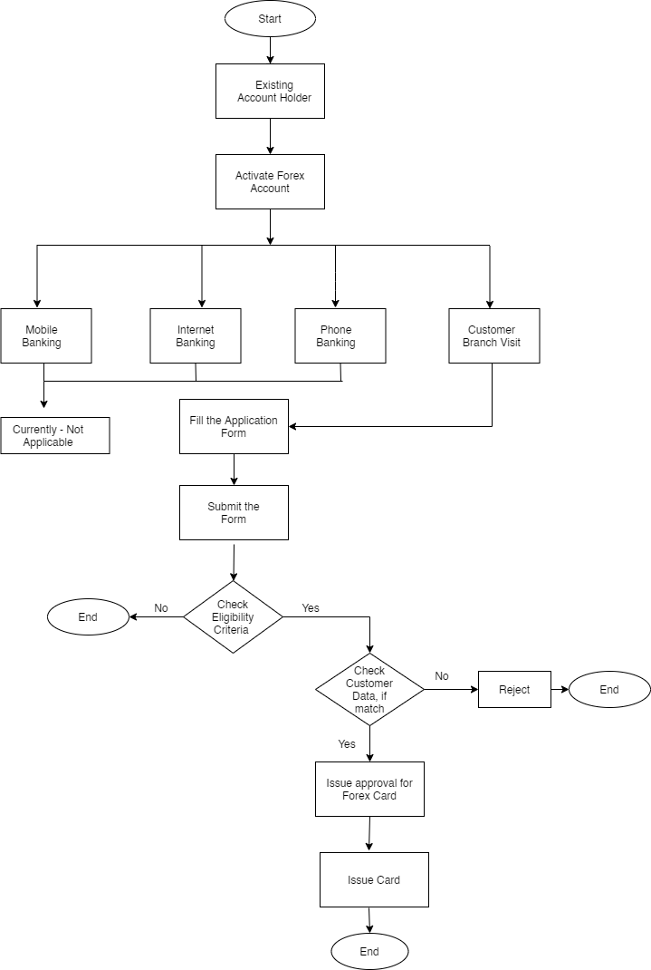

# **Application Form**

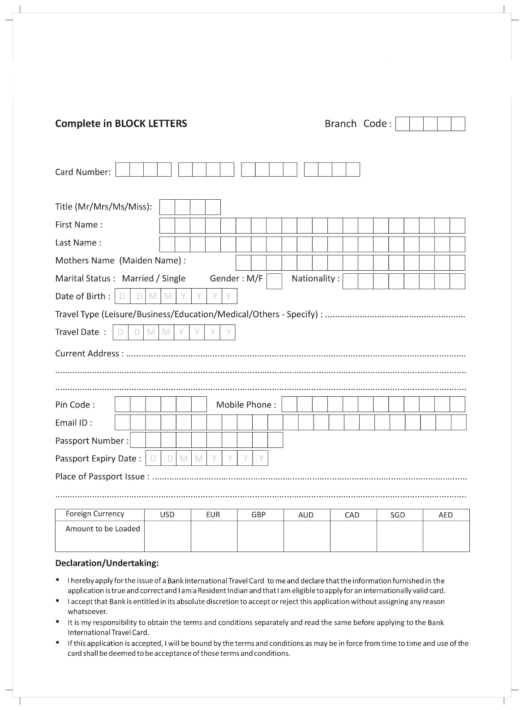

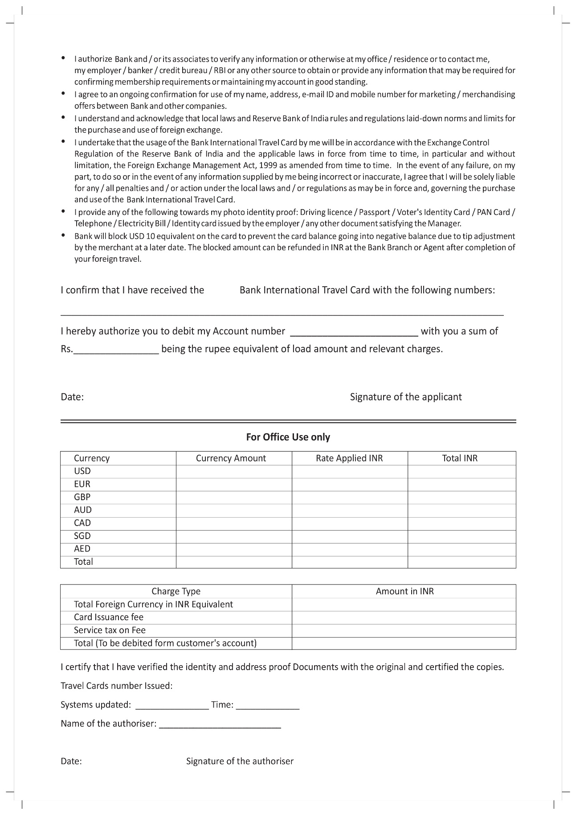

# **Sign-Off and Acknowledgment**

I understand that by agreeing to participate in this testing through the execution of the testing plan, I approve of the activities defined and authorize my department to participate as documented for the successful implementation of this solution in our department.

**Robotic Process Automation Team**

Satish Reddy C

Project Head Date: __/__/____

_____________________________